**Y-X Number**

**Input File: inE.txt**

**Description**Starting from point (0,0) on a plane, we have written all non-negative integers 0, 1, 2,... as shown in the figure. For example, 1, 2, and 3 has been written at points (1,1), (2,0), and (3, 1) respectively and this pattern has continued.

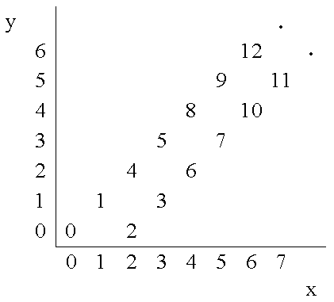

You are to write a program that reads the coordinates of a point (x, y), and writes the number (if any) that has been written at that point. (x, y) coordinates in the input are in the range 0...5000.

**Input Format**The input file (**inE.txt**) will contains multiple test cases. The first line of the input is N, the number of test cases for this problem. In each of the N following lines, there is x, and y representing the coordinates (x, y) of a point.

**Output Format**  
For each point in the input, write the number to console written at that point or write No Number if there is none.

**Sample Input**  
**2  
4 2  
3 4**

**Sample Output**  
  
**6  
No Number**